**Working with labs in this course**

Throughout this course, you will be completing labs in a virtual coding environment. The purpose of these labs is to give you an opportunity to apply what you learn. You will be doing things like creating a basic login form for a website, a table booking form and a web page for rating a video. And that's just in the first module! In module 2 you'll create a grid layout and a restaurant menu and you'll practice the transform and transition properties in CSS. And, in the final module, there is a lab that will allow you to work in VS Code for the portfolio project without downloading it to your computer.

To complete some of the labs you need to be able to see your rendered HTML in a browser. To view the rendered HTML on a web page follow the step-by-step instructions below. **Step 1:** Save the file. **Step 2:** Click on 'Go live' at the bottom right of your editor.

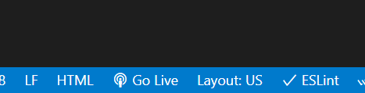

Once the server is up and running you'll see the exposed port.

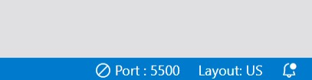

**Step 3**: Click on browser preview.

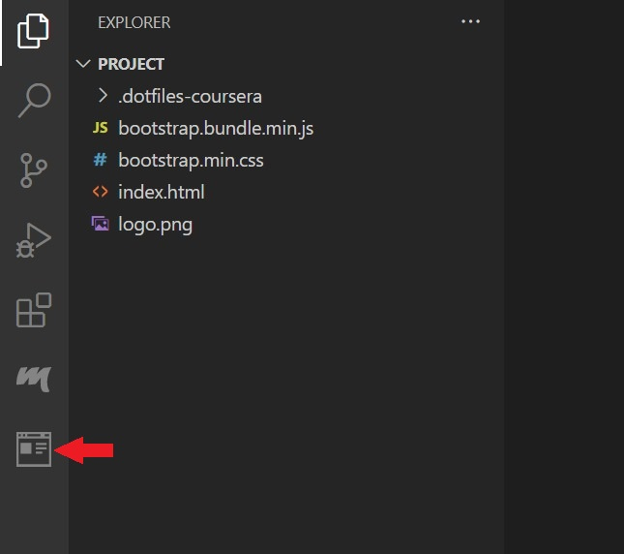

**Step 4**: Enter the url as http://localhost:5500



**Step 5**: Check that the web page displays.

After completing your lab, don't forget to close the server. You can close the server by clicking on the exposed Port number (e.g. 5500) after completing the lab.



You should see a notification like this which confirms the server has been stopped.

